
Company
Logotype

Cone Beam Computed Tomography- Report



Porur Dental X-rays & CBCT

Patient Name : Mrs. Divya Priya | Date of Report : 29.08.2024
Age/ Gender : 34 years/ Female | Region of Interest : CBCT Sectional Mandible
Referring doctor: Dr. Vikram Vishenath | Indication : I.A.Nerve proximity to 48
Clinical Notes: Nil
PATIENT INFORMATION

CBCT- Sectional Mandible provided
CBCT – IMAGE DETAILS

RADIOGRAPHIC INTERPRETATION

- The tooth 47 is present with dental caries in proximity to the pulp.
- The long axis of 48 appears to be parallel to the long axis of the adjacent tooth.
- The crown of 48 is present partially within the ascending ramus of mandible.
- The tooth 48 is present towards the lingual aspect
Width of buccal cortical bone: 2.29 mm ; Width of lingual cortical bone: 1.41 mm
- Distance between the root apex of 48 and the Inferior Alveolar Nerve canal: in contact.

RADIOGRAPHIC IMPRESSION

- Dental caries: 47
- Partially impacted tooth: 48

Kindly correlate with clinical findings


IMAGES FOR REFERENCE

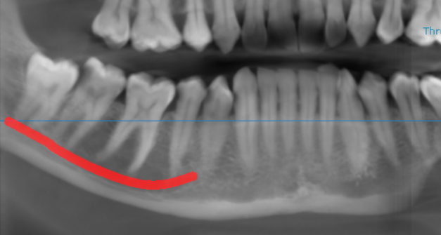
RECONSTRUCTED PANORAMIC VIEW

3-DIMENSIONAL VIEW

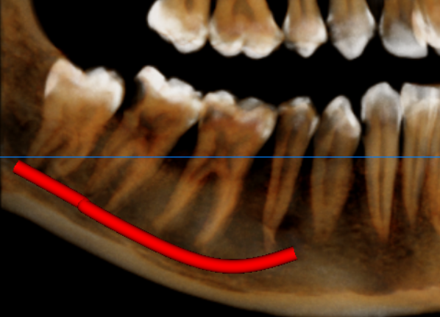

CROSS SECTIONAL VIEW

48 region- relation with the inferior alveolar nerve canal | 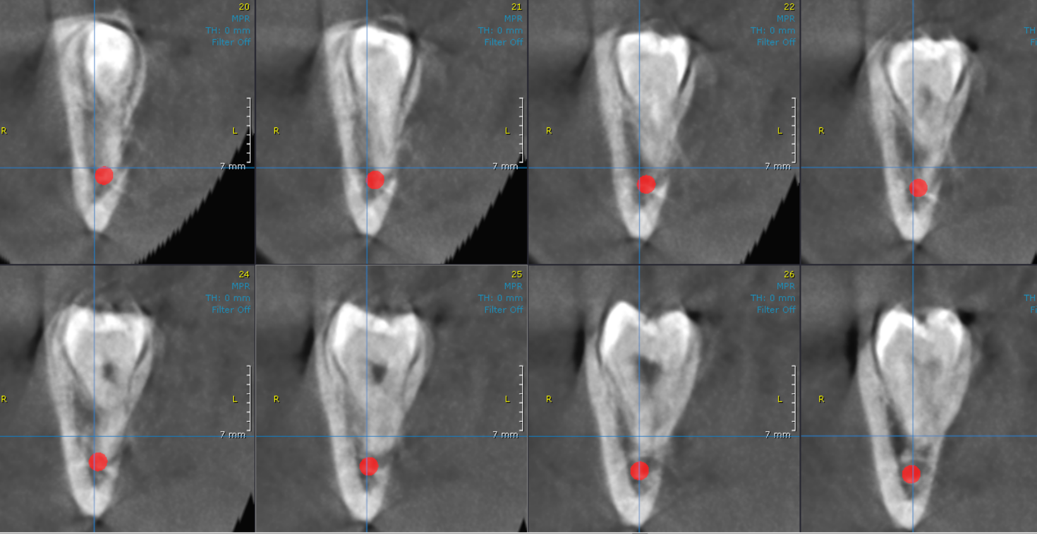

**** End of report ****

